Subject |  | Forces
Forces | Key Vocabulary
  Key vocabulary
  Gravity; gravitational force; friction; force; thrust; upthrust; air resistance; water resistance; push; pull; stationary; contact force; non-contact force; buoyancy; zero gravity; motion; unsupported force; supported force; levers; pulleys; gears; springs; fulcrum/pivot; hinge; motion; particle; surface area; Mass (g & kg); Balance;
  Scientists to consider: Galileo Galilei; Isaac Newton; Christopher Cockerell; Archimedes
 | Lesson | Lesson 1 | Lesson 2 | Lesson 3 | Lesson 4 | Lesson 5 | Lesson 6
Science  Forces | Key Objectives | To be able to explain that unsupported objects fall towards the Earth because of the force of gravity acting between the Earth and the falling object. | To be able to identify the effects of air resistance that act between moving surfaces. | To be able to identify the effects of friction between moving surfaces. | To be able to recognise that some mechanisms, including pulleys, allow a smaller force to have a greater effect. | To be able to recognise that some mechanisms, including gears, allow a smaller force to have a greater effect. |  | To be able to recognise that some mechanisms, including levers, allow a smaller force to have a greater effect.
Science  Forces | Suggested activities | Plan and carry out an experiment to find the effect of surface area on the time taken to fall of a piece of paper or an autogyro | Look at examples of air and water resistance-eg parachutes, flippers  Also look at how these can be minimised eg design of racing cars, boats, helmets etc | Look at everyday examples of friction in action. Learn how to use a forcemeter and the units used to measure a push or pull eg newtons  Plan and carry out a fair test to find out which trainer has the best grip. | Look at pulleys in action  Compare the mass needed to be placed in one cup to raise the other from the ground  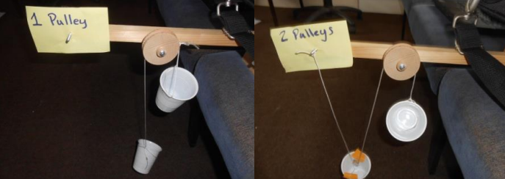 | Experiment with gears- observe and record how many times the follower turns and in which direction,  Add a different numbers of gears to see the effect  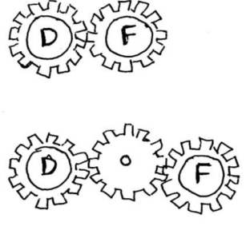 |  | Set up a simple lever using a pencil and ruler  Investigate the mass needed to be placed on one end to counterbalance a weight on the other end when the fulcrum is placed in different positions.  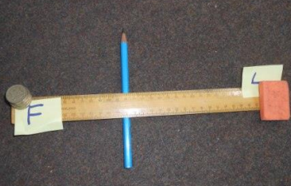
 | Assessment opportunities  Exceeding | Pupil can explain the effect of gravity on objects falling towards the earth. | Pupil can explain that the movement of objects through air, water and across surfaces is resisted by these media.  Pupil can give ideas for how the effect of air & water resistance and friction can be minimised to enable objects to move more freely through the respective media.  Pupil can explain how aerodynamic design can increase the speed of movement of objects in, over, under a range of media. | Pupil can measure accurately using a forcemeter  Pupil can draw a conclusion referring to friction | Pupil can describe how levers and pulleys work.  Pupil can explain how some mechanisms can use a small force to create a big effect.  Pupil has opportunity to experiment with different types and sizes of levers and pulleys to identify patterns in the size of force they can create. | Pupil can describe how gears work.  Pupil can explain how gears can change the speed and direction of movement  Pupil has opportunity to experiment with different types of gears to identify patterns in the movement and direction they produce |  | Pupil understands the effect of moving the fulcrum on the amount of force needed to counterbalance a weight.
 | Working scientifically | Fair testing  Taking measurements accurately  Decide which measurements to take  Identify and comment on the patterns I notice | Identify appropriate secondary sources to research ideas and ask questions | Plan when to take repeat readings | Identify and comment using appropriate language on patterns , I notice. | Decide how to record data- design table to show the speed and direction of movement |  | Use evidence from an enquiry to support or refute ideas being tested

Not on Track | On Track | Exceeding
Any additional comments

